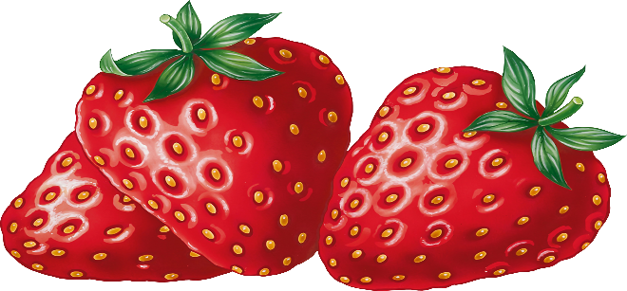

CLEVELAND COUNTY STRAWBERRY FESTIVAL
I hereby apply as a vendor for Cleveland County Strawberry Festival Saturday, May 13, 2023. Festival operations will be from 9:00AM to 4:00PM.

Business Name___________________________________________________________

Contact Person___________________________________________________________

Mailing Address___________________________________________________________

City____________________ State_________________ Zip________________________

Email___________________________________________________________________

Phone____________________________ Cell___________________________________

Briefly describe your business and list all products you will have for sale______________

_______________________________________________________________________

_______________________________________________________________________

Please print name___________________________________

Date_______________________________________________

Signature__________________________________________

Please return completed application to:

Cleveland County Fair
1751 East Marion Street
Shelby, NC 28152
Email: jennifer@ccfair.net or ccfairlacey@gmail.com

